Case Study; Logs, IOCs, Thresholds and Alerts

Scenario – Cat’s Company Breakdown

Step 1: Have the appropriate devices open and close anything that is not needed

Cat is in charge of securing a small business that uses a mix of Windows based systems, 1 Server, 1 Windows 10 Workstation and one Linux system (The Linux system of choice for this task will be KALI).
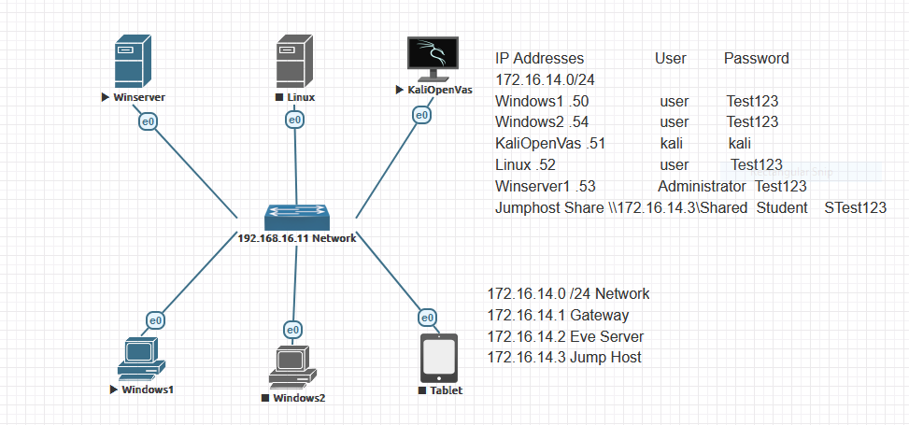
Additional information: one of the systems is a server, she wants to focus most of her attention there, though the Windows Workstation and Linux system are used for development, and the Linux system has a MYSQL database that needs to be watched.

Step 2: Ping/Scan your network to make sure that the above mentioned machines are connected

Instead of doing a ping to verify the network, the command sudo nmap -p- -O was used on the Web Host 172.16.14.0/24 in order to verify that the proper systems were open and to acquire moe information in case they might be useful in the future.
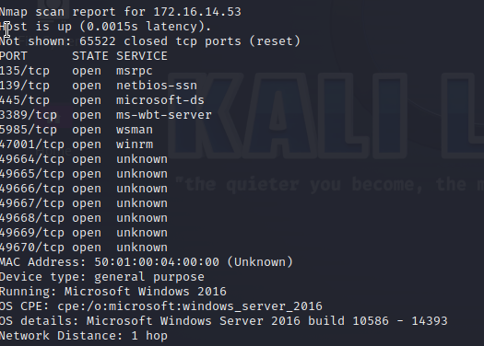
Winserver
IP: 172.16.14.53

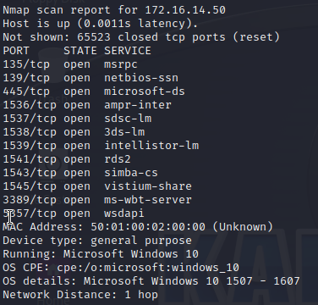
Windows1 Workstation
IP: 172.16.14.50

A ping was use on Kali and Zenmap to verify the connection

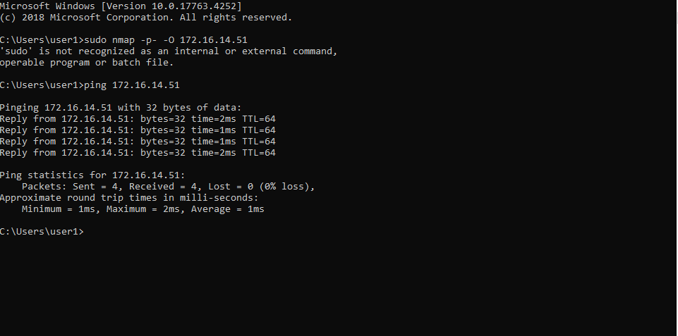
Kali
IP: 172.16.14.51

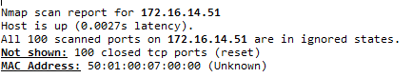

https://learn.microsoft.com/en-us/dotnet/framework/install/on-windows-10

